

SOCIETY MANAGEMENT PORTAL

Web & App



Table of Content

| Sr. No. | Particulars | Page No. |
| --- | --- | --- |
| 1 | Abstract | 2 |
| 2 | Problem Statement | 3 |
| 3 | Existing System | 3 |
| 4 | Advantage of the proposed system | 4 |
| 5 | Feature List | 5 |
| 6 | -- Society Management | 8 |
| 7 | -- Payment Management | 10 |
| 8 | -- Accounting | 12 |
| 9 | -- Amenities & Event Booking | 14 |
| 10 | -- Meetings Management | 16 |
| 11 | -- Notification | Broadcast | 18 |
| 12 | -- Visitor Management | 20 |
| 13 | -- Vendor Management | 22 |
| 14 | -- Parking Management | 24 |
| 15 | -- Document Management | 26 |
| 16 | -- Complaint Management / Helpdesk | 28 |
| 17 | -- Inventory Management | 30 |
| 18 | -- Polls Management | 32 |
| 19 | -- Gate Management | 34 |
| 20 | -- Guard Patrolling | 36 |
| 21 | -- Move in / Move out for tenants | 38 |
| 22 | -- Social Engagement | 40 |
| 23 | -- Reports | 42 |

Abstract

SocietyWale is a digital solution that aims to streamline and optimize the management and operations of residential, commercial, or mixed-use societies. This comprehensive software portal integrates a wide range of features to effectively automate and simplify various administrative tasks, fostering efficiency, transparency, and convenience for both residents and administrators.

Key features of SocietyWale include maintenance fee management, visitor tracking, complaint resolution, accounting, and communication. By centralizing these tasks onto a single platform, the software eliminates the need for manual record-keeping and paperwork, reducing the chances of errors and improving overall productivity.

Maintenance fee management is a core component of society management software, allowing administrators to efficiently track and collect fees from residents. It also offers features like online payment integration, making it convenient for residents to pay their fees through various digital payment methods.

Visitor tracking, Complaint resolution, Accounting and communication are important part of this portal to ease out the transparency between members and managing committee.

In conclusion, SocietyWale Portal streamlines and improves the management and operations of societies by automating administrative tasks and providing a centralized, efficient platform. The software enhances efficiency, transparency, and convenience, resulting in enhanced satisfaction for both residents and administrators. Its comprehensive features makes it an indispensable tool for effective society management in today's digital age.

Problem Statement

Residential, commercial, and mixed-use societies face numerous challenges in managing their day-to-day operations and effectively engaging with residents. Traditional manual processes for maintenance fee collection, visitor management, complaint resolution, and communication often lead to inefficiencies, errors, and a lack of transparency. Additionally, with the increasing reliance on digital platforms, societies need a comprehensive and user-friendly online portal to streamline their operations and enhance resident satisfaction.

A robust and user-friendly society management portal is needed to address these pain points and empower societies with a centralized platform that improves operational efficiency, fosters transparent communication, and enhances resident satisfaction.

Existing System (Notice Board System)

In current situations, society management authorities use a traditional way of communication which includes a common notice board system operated by responsible society member. Many of societies also have started using automated chat systems which are definitely useful up to certain extent but though fail to provide reliable way of communication.

Here are some basic disadvantages of these methods:

1. **Manual and Time-Consuming Processes**:   
   Traditional society management relies heavily on manual processes, such as paper-based record-keeping, receipt generation, and documentation. This can be time-consuming and prone to errors, leading to inefficiencies in managing day-to-day tasks.
2. **Lack of Automation**:   
   Without dedicated software, tasks such as maintenance fee collection, invoice generation, complaint resolution, and visitor tracking are handled manually.
3. **Limited Transparency**:   
   Traditional society management methods often lack transparency, making it difficult for residents to track their payments, report complaints, or stay updated on society announcements and events. This can result in miscommunication and reduced resident satisfaction.
4. **Inefficient Communication Channels**:   
   Without a centralized communication system, societies heavily rely on notice boards, physical notices, or word-of-mouth to convey information to residents.
5. **Security and Access Control Challenges**:   
   Managing visitor access and ensuring the security of society premises can be challenging without dedicated systems in place.

Advantage of the Proposed System

1. **Multiple Reminders**:   
   The application can provide gentle reminders through automated system till the actual event execution.
2. **Authentic and uninterrupted communication with society members**:   
   In this particular regard, it often seems that complaints by society members remain unattended by higher management and member has to suffer. The application can provide an assurance to follow up every complaint made by society member. Basically user can raise a complaint from any location irrespective of personal availability of concern person.
3. **Time saver and Go Green activity**:   
   As this is a web based communication platform. Admin can push notices, create events, and ask for complaints and many more things within a minute. Besides being paperless activity, this will be a small helping hand for Go Green activity which will avoid use of eco- destructive products.
4. **Hassle free online payment**:   
   User can make there payment via multiple payment option from anywhere and anytime. Also, keep track of payment status.

Features/Functionality of Proposed System

1. It will be a web portal and mobile app(Android & IOS)
2. There will be below user who can us this system,
   1. Super Admin | SocietyWale [SA]
   2. Area Manager [AM]
   3. Admin | Managing Committee Member [AD]
   4. Flat Owner [FO]
   5. Security Guard [SG]
3. Only Super Admin, Area Manager and Admin will have web portal access whereas Flat owner and Security Guard will use Mobile app to manage everything.
4. Here are the list of features available with the system
   * Dashboard
     + Dashboard of the system
   * Society Management
     + Add society
     + Initial settings
     + Add members
   * Payment Management
     + Online Maintenance Payment
     + Late fees calculation
     + Send reminders on due date
     + Other payments (Donation, Festival contribution)
     + Digital invoice/receipt for payment
     + Other bills like electricity, mobile bills, water bills, gas pipeline bills, etc can be pay though the portal
   * Accounting
     + Debit & Credit
     + N-format report for filling tax
     + Add bills
     + Track bills due date
     + Online bill payments (Through third party API)
     + Expense management
     + Vendor bill payments
   * Amenities & Event Booking
     + Set charges for amenities and events
     + Check availability of amenities
     + Book amenities or pay for and event online
     + Cancel bookings
   * Meetings Management
     + Schedule AGM | SGM
     + List of attendees
     + Send MOM
     + Resolution passed details
     + Add/ update / delete bylaws
   * Notification | Broadcast
     + Notifications for Maintenance charges
     + Notifications for Meetings
     + Other notifications
     + Send notifications to individual or entire society or group of members
   * Visitor Management
     + Guest (Pre-approved)
     + Visitor (Need to record and approve)
     + Delivery Person
     + Housekeeping staff
     + Staff attendance
     + Add visitors
     + Entry and exit of visitors
     + Verification with flat owners
     + One time visitor | Repeated visitor
   * Vendor Management
     + Manage vendor
     + Add vendor
   * Parking Management
     + Manage parking slots
     + Assign parking slots to flat owner
     + Add guest parking
     + Manage In/ out of vehicle
   * Document Management
     + Add document
     + Share document
     + Notification of expiry of document
   * Complaint Management / Helpdesk
     + Add complaint mapped to specific person
     + Complaint management on different level
     + Complaint follow-up
     + Complaint resolution
     + Complaint Closure
   * Inventory Management
     + Add inventory items
     + Reminders setup for threshold values
   * Polls Management
     + Create poll
     + Set rule
     + Broadcast result
   * Gate Management
     + Types
       - One gate one building
       - Multiple gate one building
       - Multiple gate multiple building
     + Assign Security Guard to every gate
     + Manage time and days for each security guard
     + Visitors entry and exits
     + Vehicle entry and exits
   * Guard Patrolling
     + Guard patrolling with a help of QR codes
   * Move in / Move out for tenants
     + Add tenant details
     + Add rent agreement
     + Add move in / move out entry
     + Digitized rental agreement
     + Non occupation charges to give flat on rent
   * Social Engagement
     + One default group for whole society
     + Create group with selected people from the society
     + Chat with text, images and video will be possible
   * Reports
     + Audit report in N-format
     + Debit| Credit
     + Profit & Loss
     + Area wise society list
     + Revenue generation (Yearly, Monthly)
5. Society Management

| Access For: | Super Admin | Area Manager |
| --- | --- |

* + - Add Complex
    - Add society
    - Initial settings
    - Add members

Flow for Super Admin

* First step will be adding complex ( area where one or more than one societies are covered);
* Add complex step can be skip if it is a single society or society without wings (If any society has multiple wings but all wings combine to one society and managed by one committee only, it will treat as single society);
* Basic details for society will be added like society name, Address, contact details and other relevant details of the society;
* After adding society details, will add managing committee members details and add them as a user and admin for that society;
* Here we will add how many gates does that society has and add all amenities along with the charges if any;
* Last and important step in this module will be to add members(flat owners) with the portal
  + Flat owners name(Name, flat number and contact details)
  + Family members details
  + Flat - Self-occupied or rented
  + If rented, rental agreement and other details
  + Housekeeping and other staff details
  + Maintenance charges details

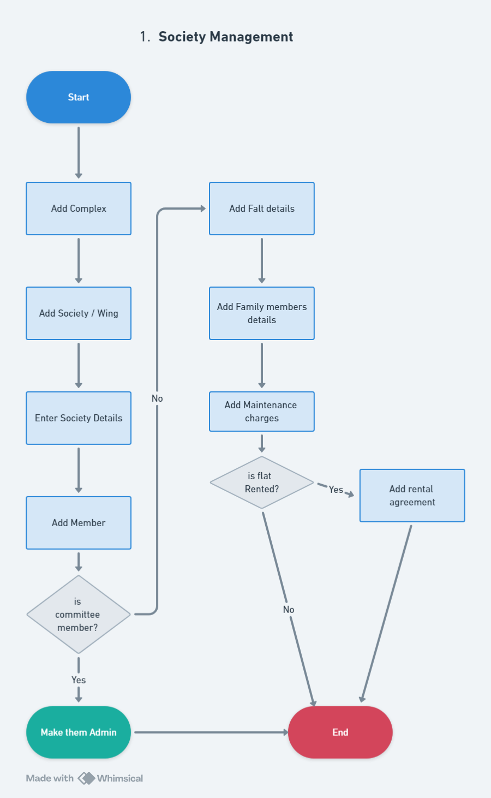

1. Payment Management

| Access For: | Super Admin | Area Manager | Admin | Flat Owner |
| --- | --- |

* + - Online Maintenance Payment
    - Late fees calculation
    - Send reminders on due date
    - Other payments (Donation, Festival contribution)
    - Digital invoice/receipt for payment
    - Other bills like electricity, mobile bills, water bills, gas pipeline bills, etc. can be pay though the portal (Refer googlpay)

Flow for Super Admin | Area Manager | Admin

* Payment gateway will be connected with society and any member makes payment it will be directly deposited to society bank account;
* Once the society and all members added to the portal, maintenance will be added as per below conditions
  + Fixed amount for every flat
  + Different amount for every flat
  + Variable amount for each flat based on area of that flat
  + Amenities charges can be added to maintenance charges
* Due date for every month can be set and if it passed late fee will be added to the maintenance charges;
* Late fee will be added automatically based on date of payment;
* Admin can schedule regular reminders for payment;
* Member will get different payment options for making the payment like credit/debit card, net banking, UPI, etc.
* As this will be online payment, once the payment successful member will get digital invoice for the same;
* Apart from the Maintenance charges, member can pay Non-occupation charges, donations, and other payment towards society through portal;
* Other than society bills, member can pay some other bills through app only.

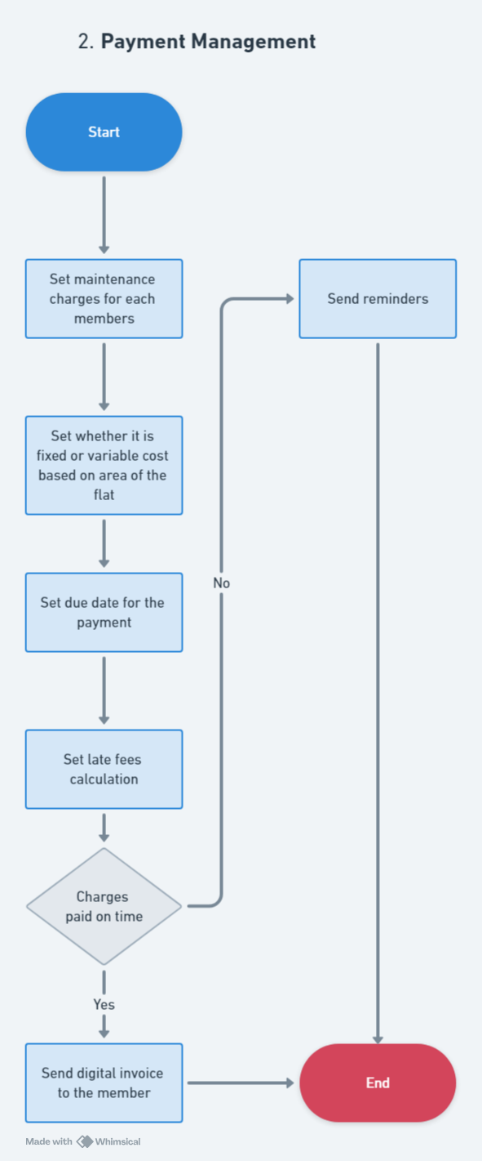

1. Accounting

| Access For: | Super Admin | Admin |
| --- | --- |

* + - Debit & Credit entry
    - N-format report for filling tax
    - Add bills
    - Track bills due date (reminder)
    - Online bill payments (Through third party API)
    - Expense management
    - Vendor bill payments

Flow for Super Admin

* Admin can add all income & expenses to the system to track debit & credit for financial accounting;
* Admin can add bills like water bill, property tax, electricity bills, etc. along with due dates, so that bills can be track;
* There will be online payment option to make the payment for all bills and that will treat as expenses/out money;
* All the vendor payment can be manage through the portal;
* System will generate N-format report for filling the tax.   
    
    
    
    
    
    
    
    
    
    
    
    
    
    
    
    
    
    
    
    
    
  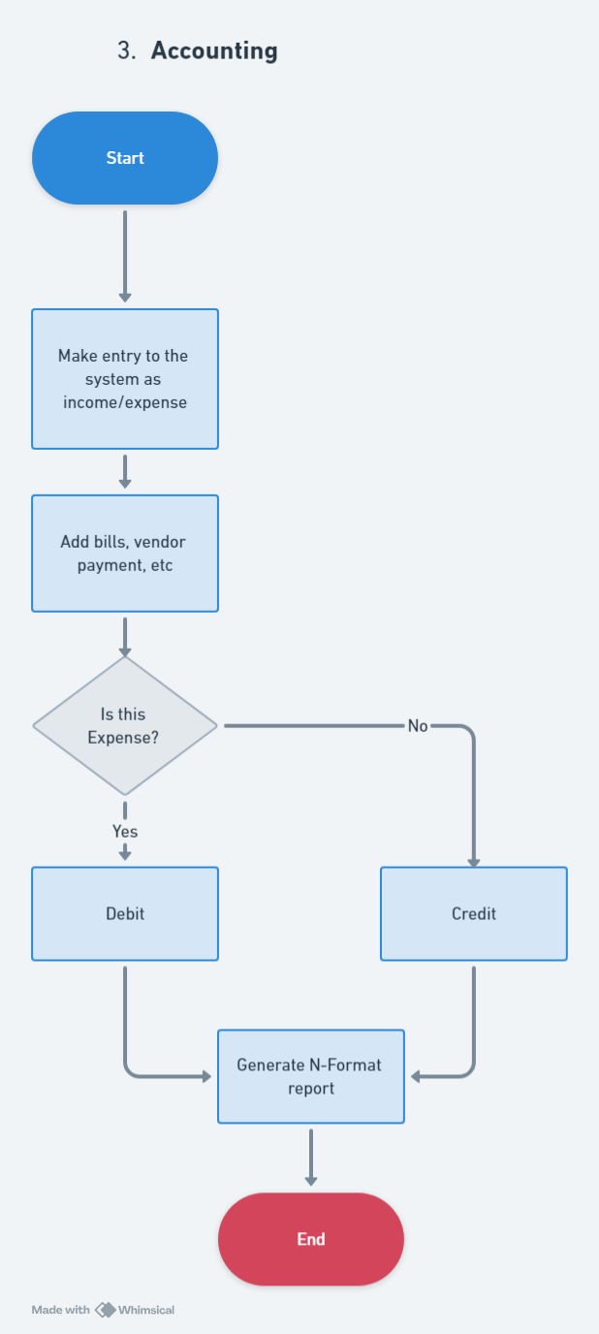

1. Amenities & Event Booking

| Access For: | Admin | Flat Owner |
| --- | --- |

* + - Set charges for amenities and events
    - Check availability of amenities (Calendar)
    - Book amenities or pay for and event online
    - Cancel bookings

Flow for Admin & Flat owner

* Admin can add/list all amenities with the system
* Admin can add new event that is going to happen in the society
* Admin can set whether any specific amenity is paid or free to use, same is applicable for event as well
* Admin will set the pricing/charges for amenities and events as per hour or per day for the member of the society
* Flat owner can check the availability of amenities on any specific days for booking the slot
* If amenities are available on desire date and time then flat owner can select the amenity along with date and time and pay the booking fees if that amenity/event is paid
* Booking payment will be paid online and once the payment is successful amenity will be book for that flat owner on that respective slot
* If slot is shown booked then other member cannot book the same slot
* Admin can approve/disapprove the booking
* Flat owner can cancel the booking as well through the system

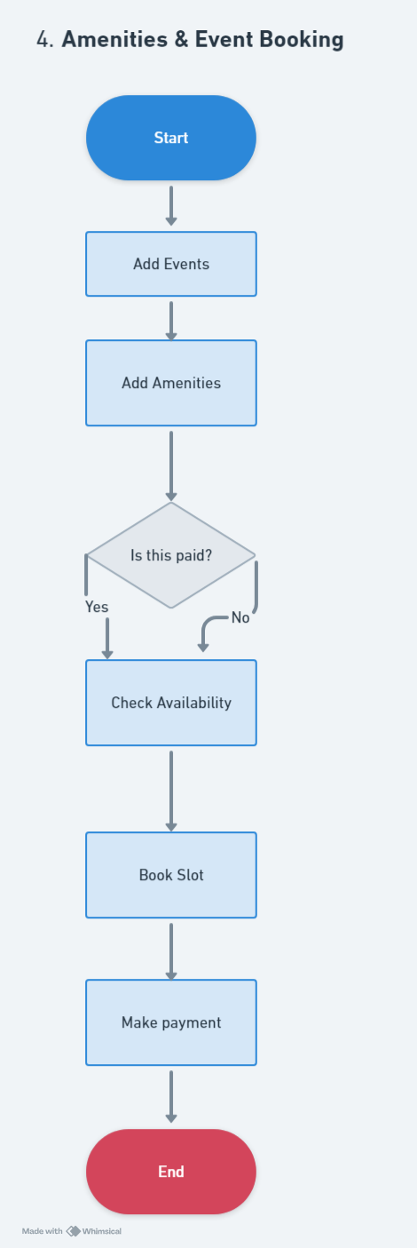

Meetings Management

| Access For: | Admin | Flat Owner |
| --- | --- |

* + - Schedule AGM | SGM
    - List of attendees
    - Send MOM
    - Resolution passed details
    - Add/ update / delete bylaws

Flow for Super Admin

* Admin can schedule AGM | SGM, select date, time and venue
* During the meeting, admin can add the attendees
* There is a provision to add MOM for the AGM| SGM
* If society wanted to pass any resolution then that can be added with suggested by and supported by details
* If any bylaws added that will be available for all members if the society

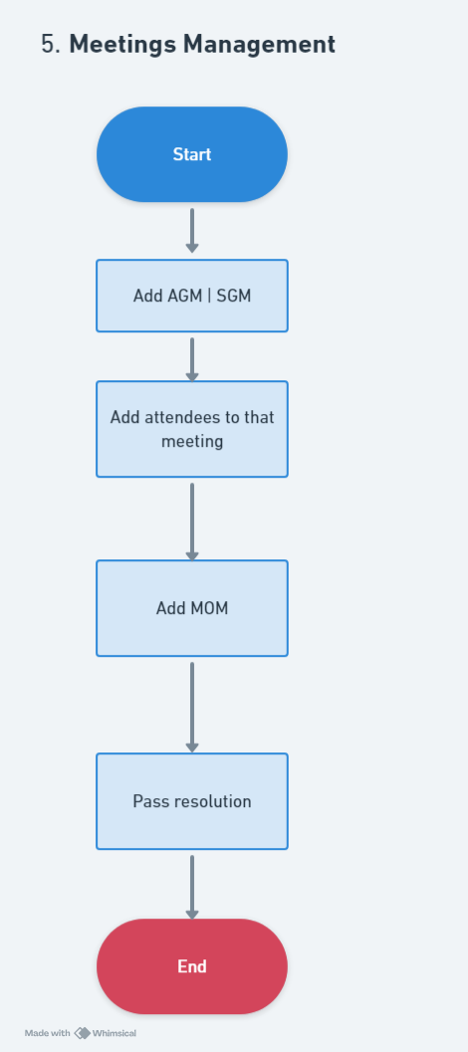

1. Notification | Broadcast

| Access For: | Admin |
| --- | --- |

* + - Notifications for Maintenance charges
    - Notifications for Meetings
    - Other notifications
    - Send notifications to individual or entire society or group of members

Flow for Admin

* There are automated notification and manual notification in the portal
* Notification can be send instantly or notification can be schedule as well
* Notification can be send to individual or send to all members
* Notification can be for maintenance due or meetings or other important info to the society member

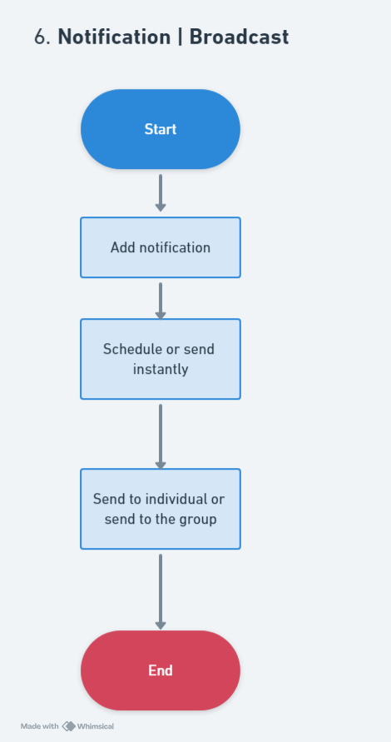

1. Visitor Management

| Access For: | Admin | Security Guard |
| --- | --- |

* + - Type
      * Guest (Pre-approved)
      * Visitor (Need to record and approve)
      * Delivery Person
      * Housekeeping staff
    - Add visitors
    - One time visitor | Repeated visitor
    - Entry and exit of visitors
    - Verification with flat owners
    - Staff attendance

Flow for Admin

* There will be four type of visitors to the society[guest, visitor, delivery person & Housekeeping staff]
* Guest and housekeeping staff are already added to the system, whereas visitor and delivery person will be added at the time he/she arrives at the society. This will be done by security guard at the society gate/entry
* Admin can add visitor with some basic details like name, contact number and flat he/she wants to visit
* Visitor can be verified by checking phone number by sending OTP and photo can be click for that visitor, just to keep the record
* Admin can define if the user is one time or frequent visitor
* Flat owner will get notification that visitor came to visit him and after approval only that visitor will be allow to enter the premise
* Housekeeping staff will be treated as repeated visitor and in/out time will be maintain
* Housekeeping staff will be link to one or multiple flats

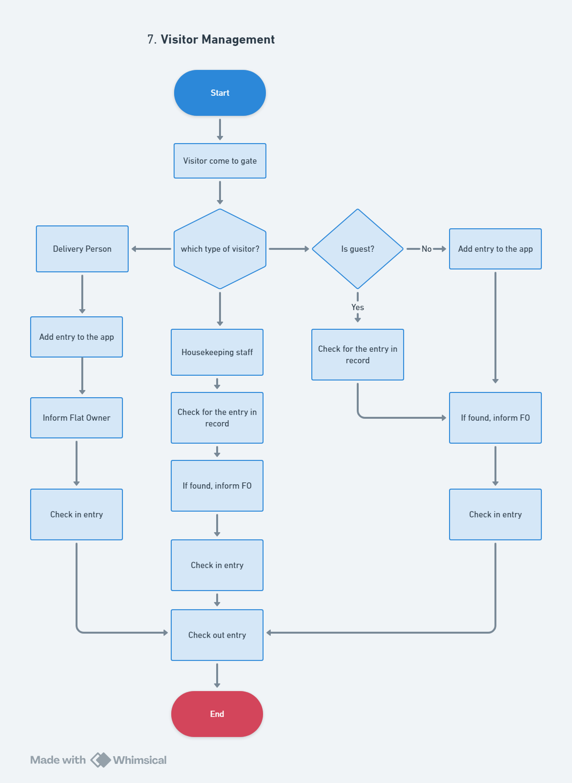

1. Vendor Management

| Access For: | Admin |
| --- | --- |

* + - Manage vendor
    - Add vendor
    - Generate bill for his service

Flow for Admin

* Admin can add different vendors to the society
* Maintain all details along with product/services offered by that vendor
* Admin can generate invoice for the vendor
* Admin can keep track of vendor payment and contracts

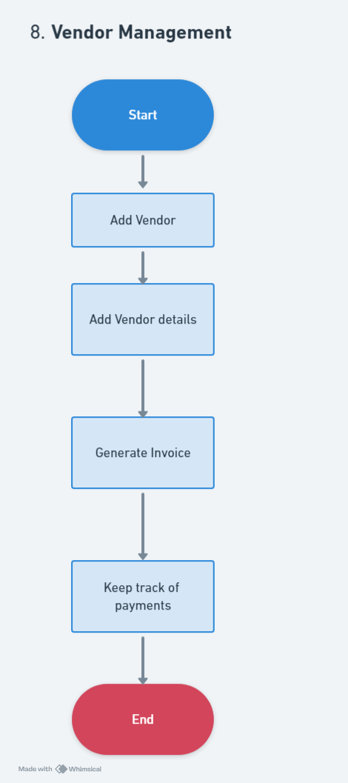

1. Parking Management

| Access For: | Admin | Flat owner | Security Guard |
| --- | --- |

* + - Manage parking slots
    - Assign parking slots to flat owner
    - Add guest parking
    - Manage In/ out of vehicle

Flow for Admin

* Admin add number of parking available in the society. Also, mentioned how many members parking and how many guest parking available in the society
* Members parking, each parking will be connected with the flat owner
* Admin can allow outsider/guest to park in the society parking by allowing guest parking with limited time period and this will be chargeable
* Even if needed members parking also can be made chargeable

Flow for Flat Owner

* Flat owner can see which parking slot assign to him
* Flat owner can check in/out time for his own vehicle for last 7 days

Flow for Security Guard

* For Members parking
  + For members parking, Guard will enter in/out time for vehicle
  + In/out time can be maintain for last 7 days
* For Guest parking
  + Guard can enter the details of guest and after confirming with Admin, guest vehicle will be register with society
  + Security Guard will assign parking slot to that guard vehicle for limited time period
  + If guest parking is chargeable then security guard will collect charges from the guard
  + Guard will maintain In/out time for guest vehicle

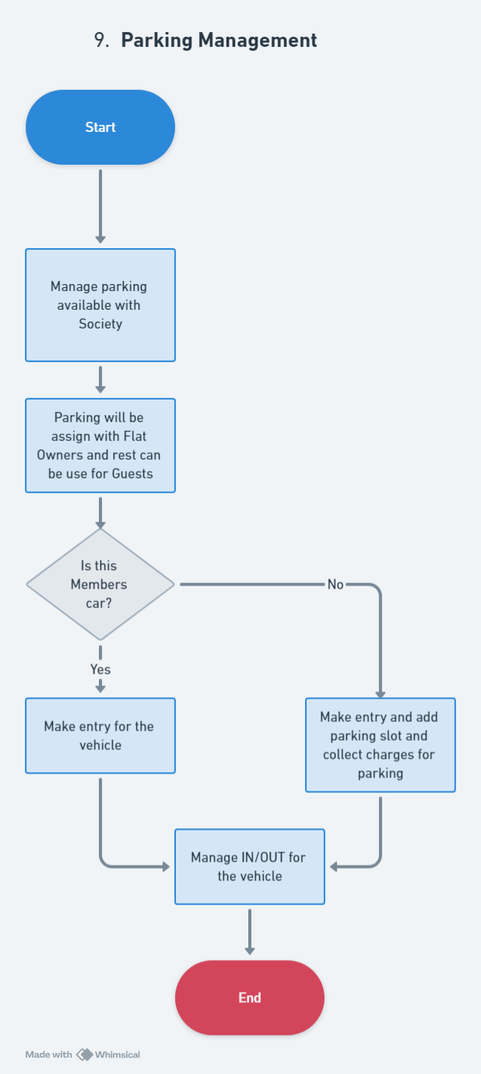

1. Document Management

| Access For: | Admin | Flat Owner |
| --- | --- |

* + - Add document
    - Share document
    - Notification of expiry of document

Flow for Admin

* Admin can add all the society documents to the system
* Admin needs to scan or upload PDF version of the document and upload the same to the system
* There is an option to share the document with other members of the site. Admin can share any society document with others
* Admin can put expiry date to the document(licences) if require, so that on due date renewal can be done

Flow for Flat Owner

* Flat Owner can upload his own document to the system (like property card, Aadhar card, bills, etc.)
* He can share any document with anyone within the society
* Flat owner will get notification, if any document has due date for renewal

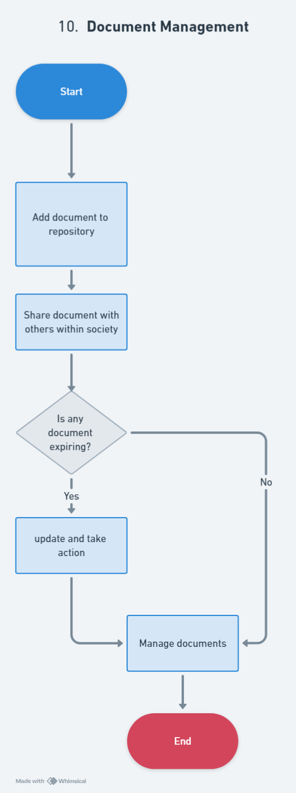

1. Complaint Management / Helpdesk

| Access For: | Admin | Flat Owner |
| --- | --- |

* + - Add complaint
    - Complaint follow-up
    - Complaint resolution
    - Complaint Closure

Flow for Flat Owner

* Flat Owner can add complaint to the society
* For added complaint, committee members will get the notification
* Flat Owner can do a follow up for complaint if that was not solve within specified time
* Flat Owner will receive solution from Admin, so that complaint can be treat as resolve
* Once Flat Owner got the solution, that complaint can be closed

Flow for Admin

* Admin will receive notification if any member add new complaint to the system
* Admin will check and provide solution for that complaint
* Once Flat Owner is satisfied with the solution then Admin can close that compliant as resolved

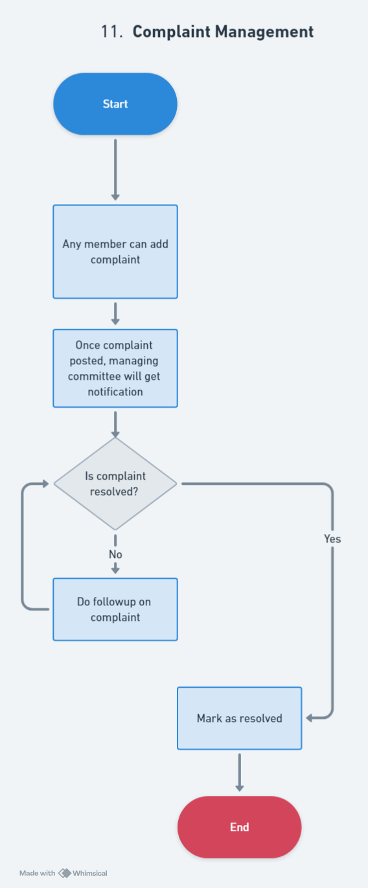

1. Inventory Management

| Access For: | Admin |
| --- | --- |

* + - Add inventory items
    - Add quantity, exp date (if any)
    - Reminders setup for threshold values

Flow for Admin

* Admin can manage the inventory for the products used for society
* Admin can add inventory item name, quantity, expiry date and minimum quantity when that product need refill
* Admin can setup reminders for threshold value, once product reach that value admin will be notified for the same
* Admin can add and delete inventory quantity as and when use

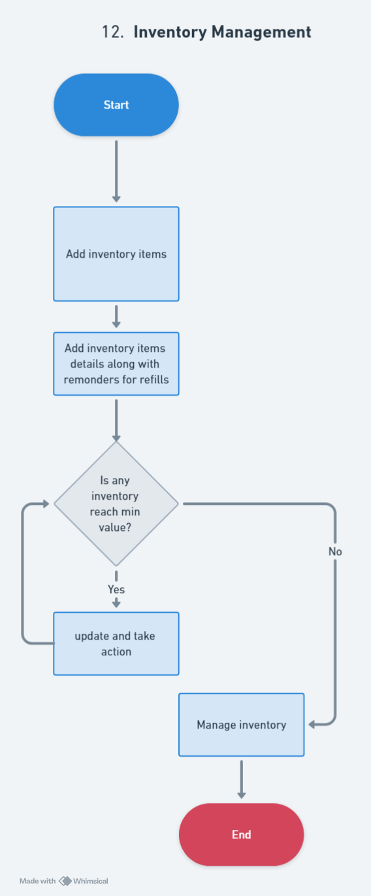

1. Polls Management

| Access For: | Admin | Flat Owner |
| --- | --- |

* + - Create poll
    - Set rule
    - Broadcast result

Flow for Admin

* Admin can create poll
* Poll can have multiple option to choose
* Admin can set rule for any poll like whether poll can be single option or multiple option, poll end date, etc.
* Once that poll reach the end date, system will generate the poll result and that result will be available for all the members of the society

Flow for Flat Owner

* Once any poll added to the system, Flat Owner will get notification for the same and he will be prompt to participate in the same
* Flat Owner can cast his vote for that poll
* After poll ends, Flat Owner can see the result for that poll

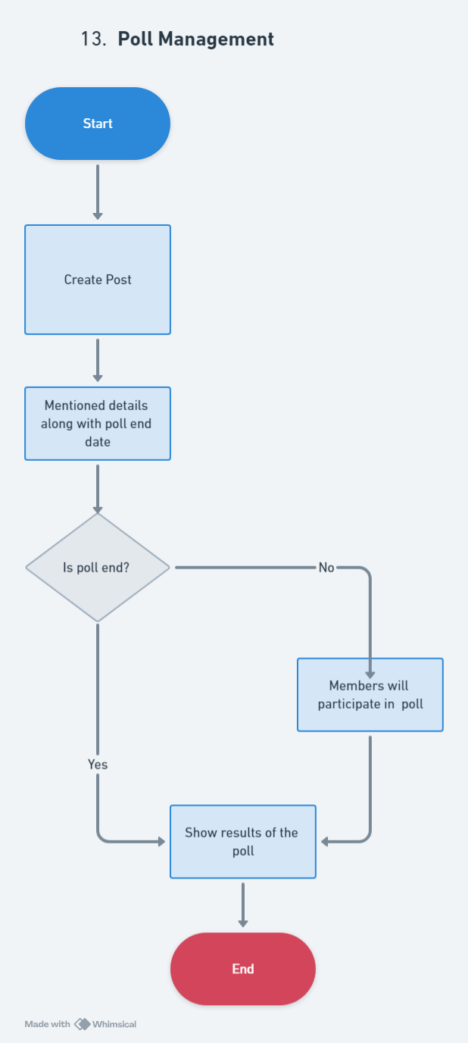

1. Gate Management

| Access For: | Admin | Security Guard |
| --- | --- |

* + - Types
      * One gate one building
      * Multiple gate one building
      * Multiple gate multiple building
    - Assign Security Guard to every gate
    - Manage time and days for each security guard
    - Visitors entry and exits
    - Vehicle entry and exits

Flow for Admin

* Admin can add one gate or multiple gate for entry to the society
* Admin can assign security Guard to each gate
* If Security guards are working in different shifts then those will be added as per security guards
* Admin can check visitors and vehicle entries for current and past days

Flow for Security Guard

* Security Guard will login himself with the app
* Security guard will maintain entry and exit of every visitor
* Security Guard will enter below details for each visitor
  + Name
  + Contact number – that can be verify by OTP
  + Photo – can be taken through mobile
  + Flat, visitor wants to visit
* Security Guard will take a record for vehicle as well and enter below details
  + Whether vehicle belongs to member or guest
  + If member, then just do entry and exit
  + If guest, assign parking slot

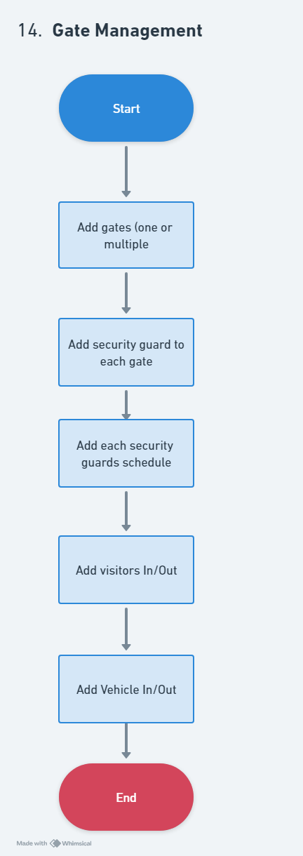

1. Guard Patrolling

| Access For: | Admin | Security Guard |
| --- | --- |

* + - Guard patrolling with a help of QR codes

Flow for Security Guard

* There will be QR code pasted on different location within the society premises
* Security Guard has to scan that QR code while patrolling in the society

Flow for Admin

* Admin can check the record where Security Guard has done the patrolling properly or not
* Admin check record for multiple Security Guards

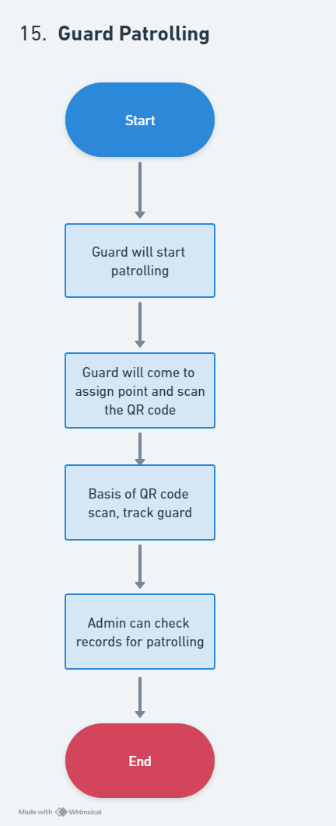

1. Move in / Move out for tenants

| Access For: | Admin | Flat Owner |
| --- | --- |

* + - Add tenant details
    - Add rent agreement
    - Add move in / move out entry
    - Digitized rental agreement
    - Non occupation charges to give flat on rent

Flow for Flat Owner

* Flat Owner can add tenants details
* Add tenants document along with rental agreement
* Flat Owner can mentioned move in / move out entry to the system
* Flat Owner can generate digital rental agreement with the system
* Flat Owner need to make the non-occupation charges to the society as decided through online option available within system

Flow for Admin

* Admin will check all the tenant detail

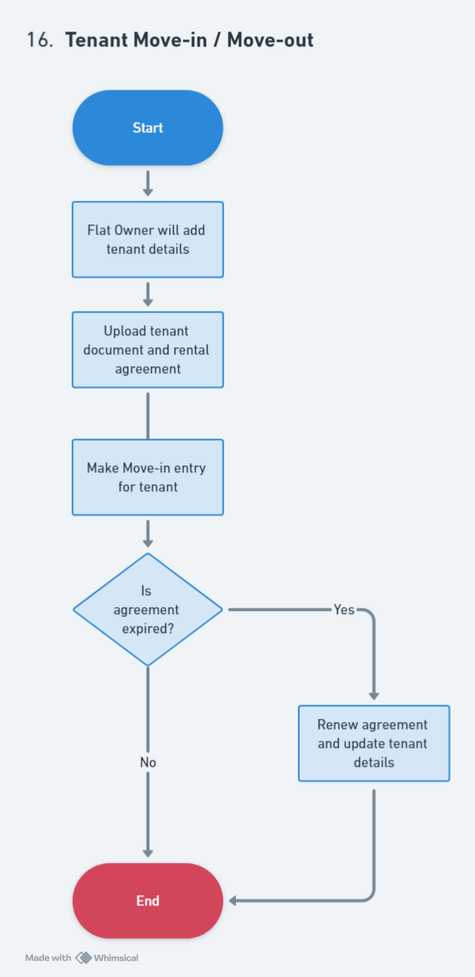

1. Social Engagement

| Access For: | Admin | Flat Owner |
| --- | --- |

* + - One default group for whole society
    - Create group with selected people from the society
    - Chat with text, images and video will be possible

Flow for Admin & Flat Owner

* There will be one default chat group where all society members listed and they can chat with each other
* Chat will have options to use,
  + Text
  + Images
  + Video
* Members can create their own group to chat internally

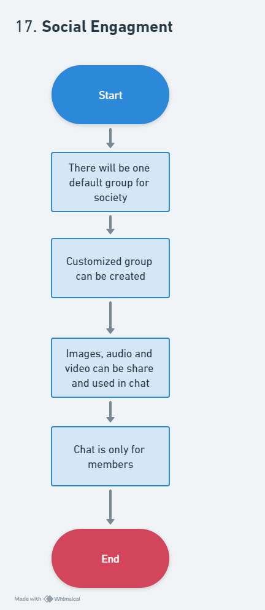

1. Reports

| Access For: | Super Admin | Area Manager | Admin |
| --- | --- |

* + - Audit report in N-format
    - Debit| Credit
    - Profit & Loss
    - Area wise society list
    - Revenue generation (Yearly, Monthly)

Flow for Super Admin | Area Manager | Admin

* There will be different report can generated as per the role user will sign in with portal
* Below reports will be available,
  + Audit report in N-format
  + Debit | Credit
  + Area wise society list
  + Revenue generation of society
  + Etc.